SUBIDA DO FRONTEND (DIST) NO http-server LOCAL
- Frontend – IntelliJ

environment.prod.ts

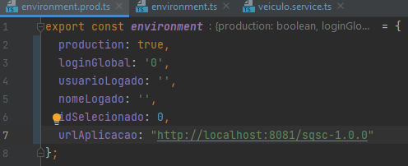

environment.ts
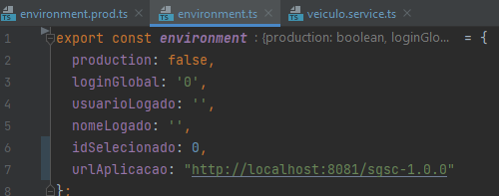

Exemplo do service:
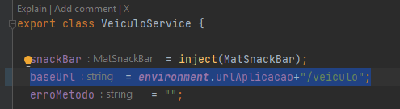

Gerando a pasta “dist”
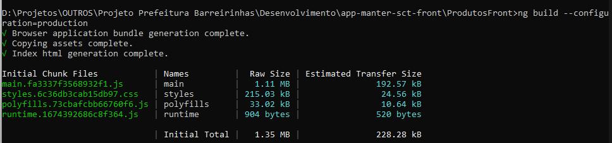

Rodando o http-server

